UAT Implementation Step

- Delete file IFRS.WebUI.Dll, IFRS.WebUI.Pdb di bin production

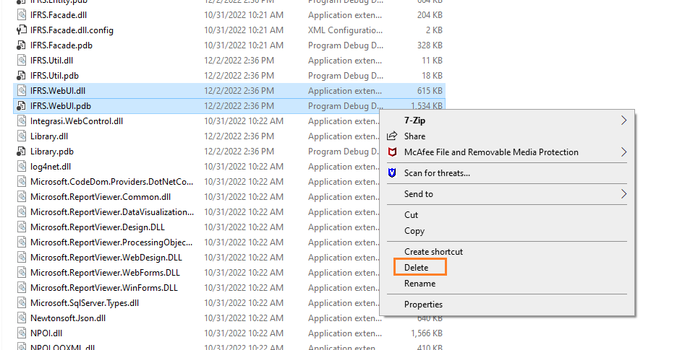

- Copy file IFRS.WebUI.Dll, IFRS.WebUI.Pdb pada D:\PSAK73\bin production ke source code folder bin pada server production

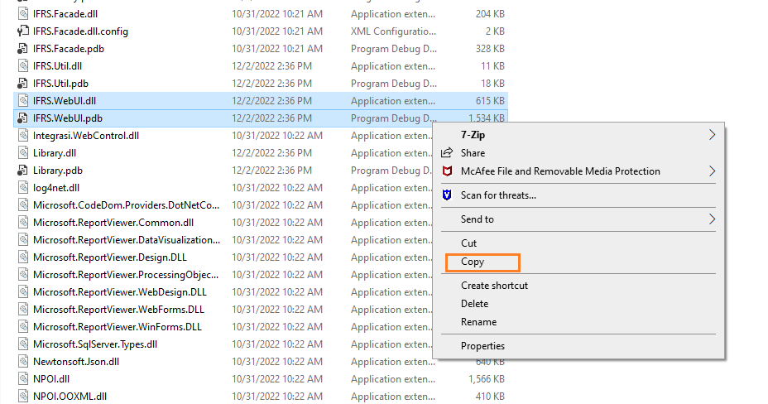

- Testing akses https://10.197.18.11:8011/ buka menu view attachmet (Client)

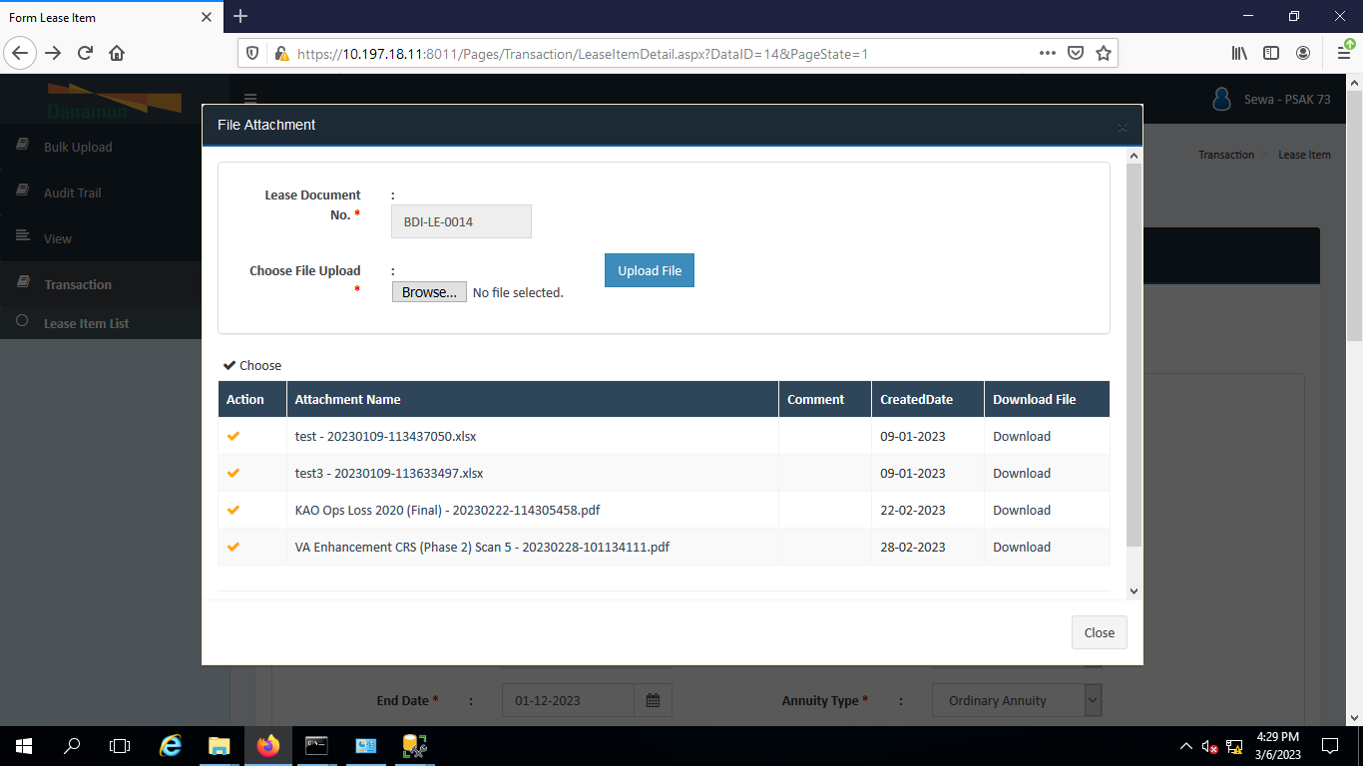

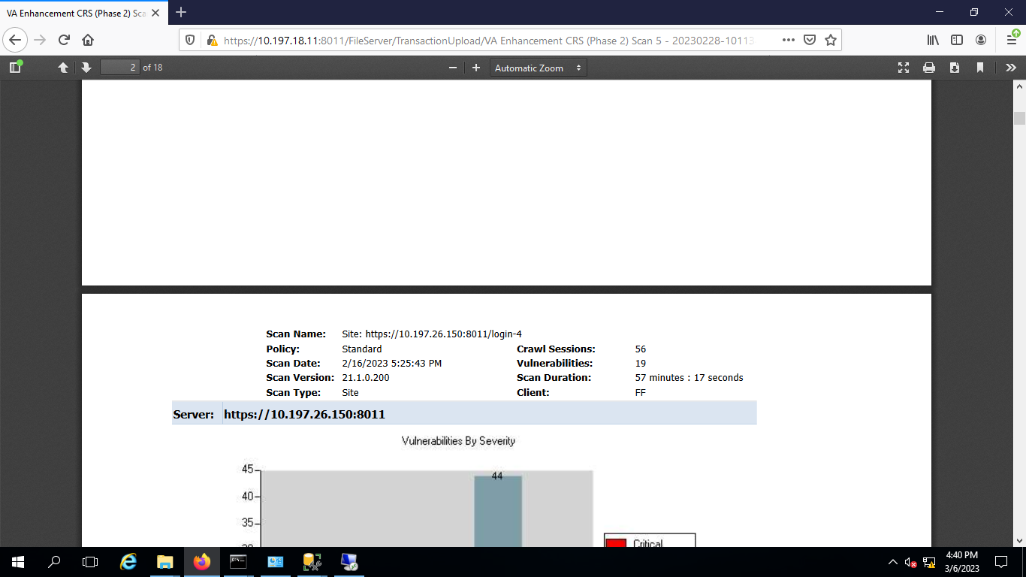

BackUp
- Mempersiapkan object IFRS.WebUI.Dll, IFRS.WebUI.Pdb

- Create folder D:\PSAK73\bin di production
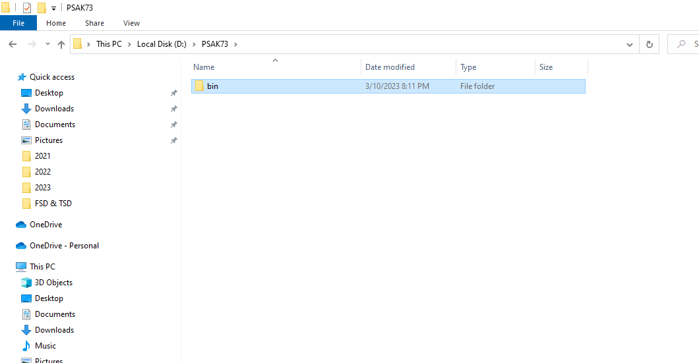

- Copy file IFRS.WebUI.Dll, IFRS.WebUI.Pdb di scource code bin pada local ke D:\PSAK73\bin production

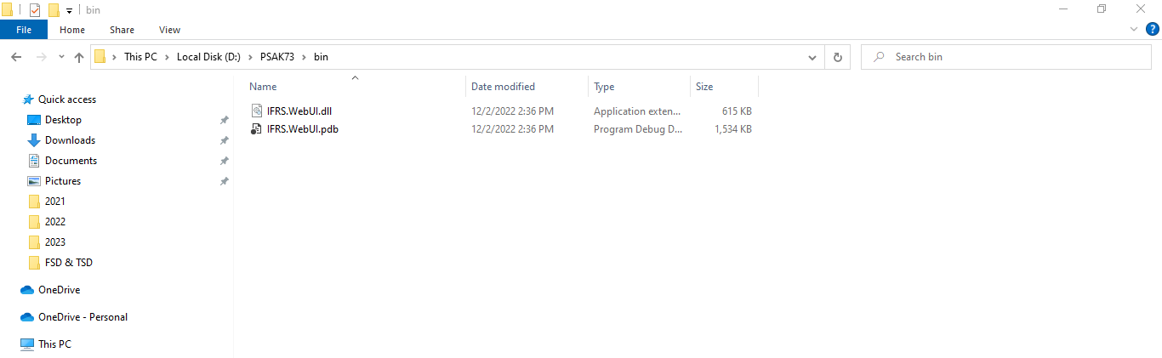

- Create folder D:\PSAK73\bin_old di production

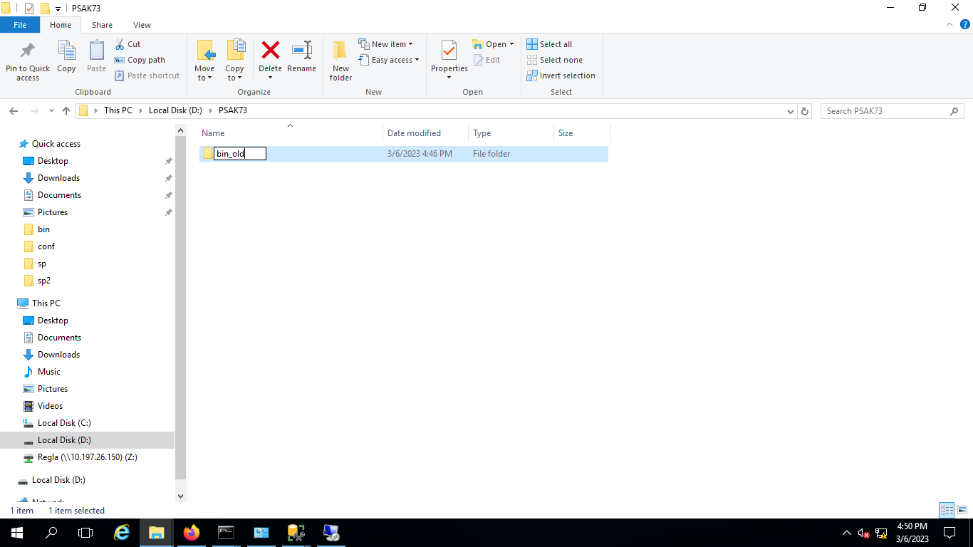

- Copy file IFRS.WebUI.Dll, IFRS.WebUI.Pdb di scource code bin pada local ke D:\PSAK73\bin_old production

